Tables
Parameter | Est. | SE | %RSE | Back-transformed(95%CI) | BSV(CV%) | Shrink(SD)%
log Cl | 1.37 | 0.0298 | 2.17 | 3.94 (3.71, 4.17) | 32.6 | 1.94%<
log Vc | 4.2 | 0.0295 | 0.703 | 66.6 (62.8, 70.5) | 32.3 | 2.46%<
log Q | 1.38 | 0.0547 | 3.96 | 3.98 (3.57, 4.42) | 32.7 | 40.5%>
log Vp | 3.88 | 0.0348 | 0.899 | 48.3 (45.1, 51.7) | 27.5 | 28.4%=
RSV | 0.196 |  |  | 0.196
Table . Parameter Estimates

Figures

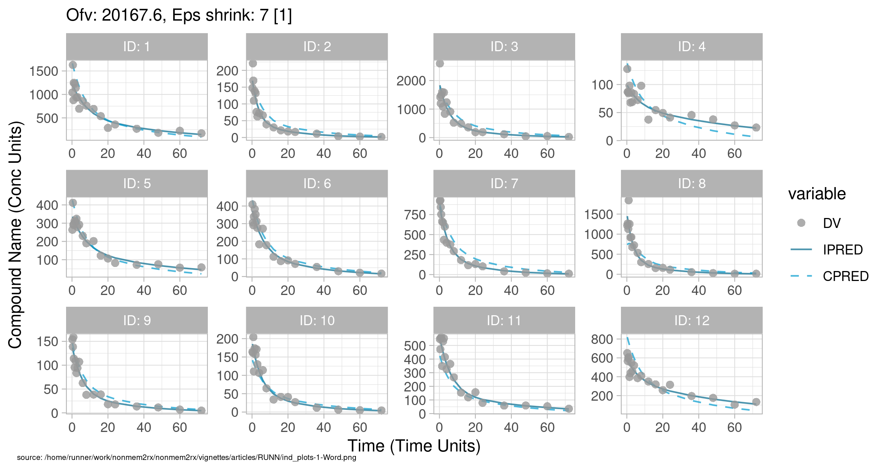
Figure . Individual and population prediction overlay

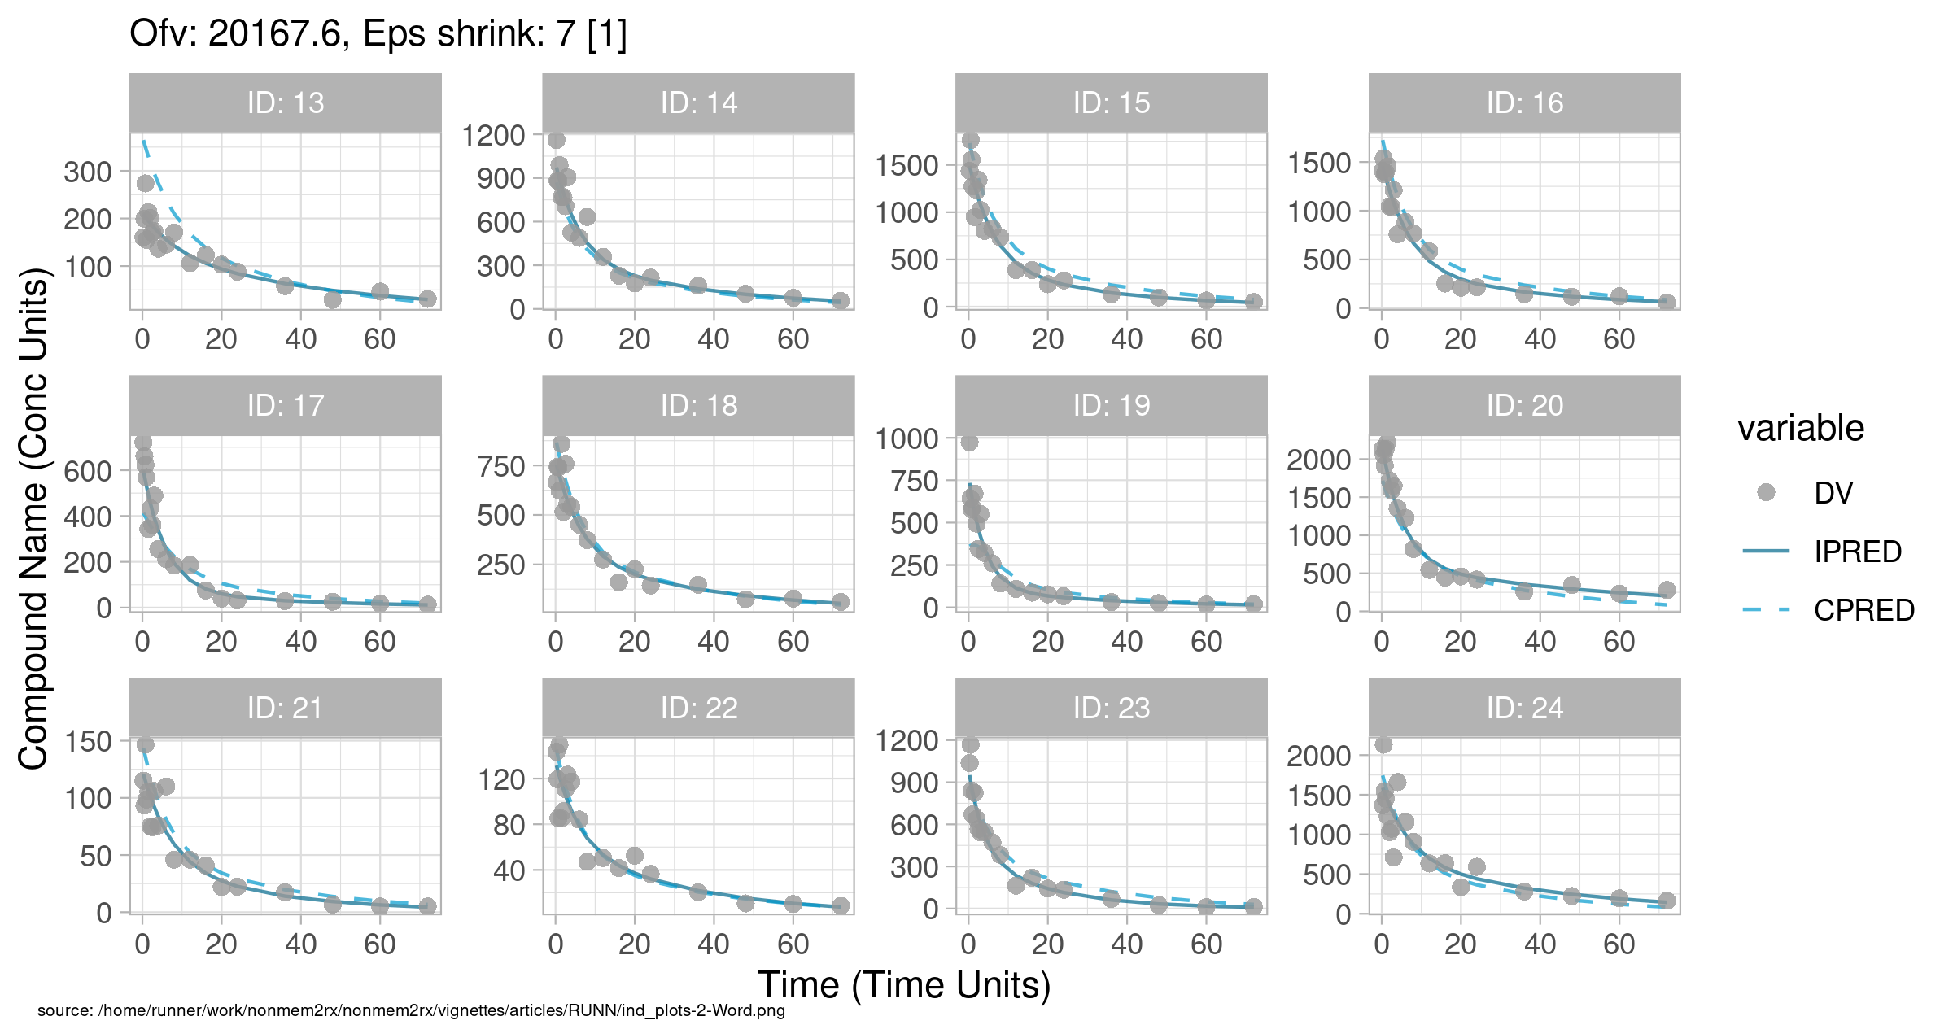
Figure . Individual and population prediction overlay

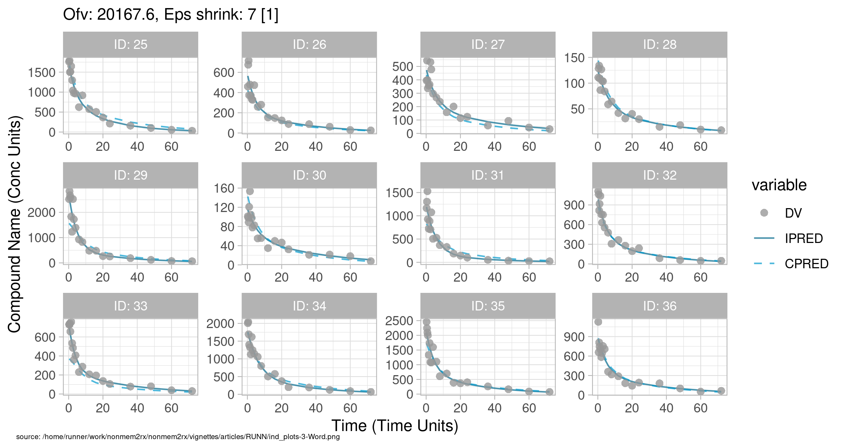
Figure . Individual and population prediction overlay

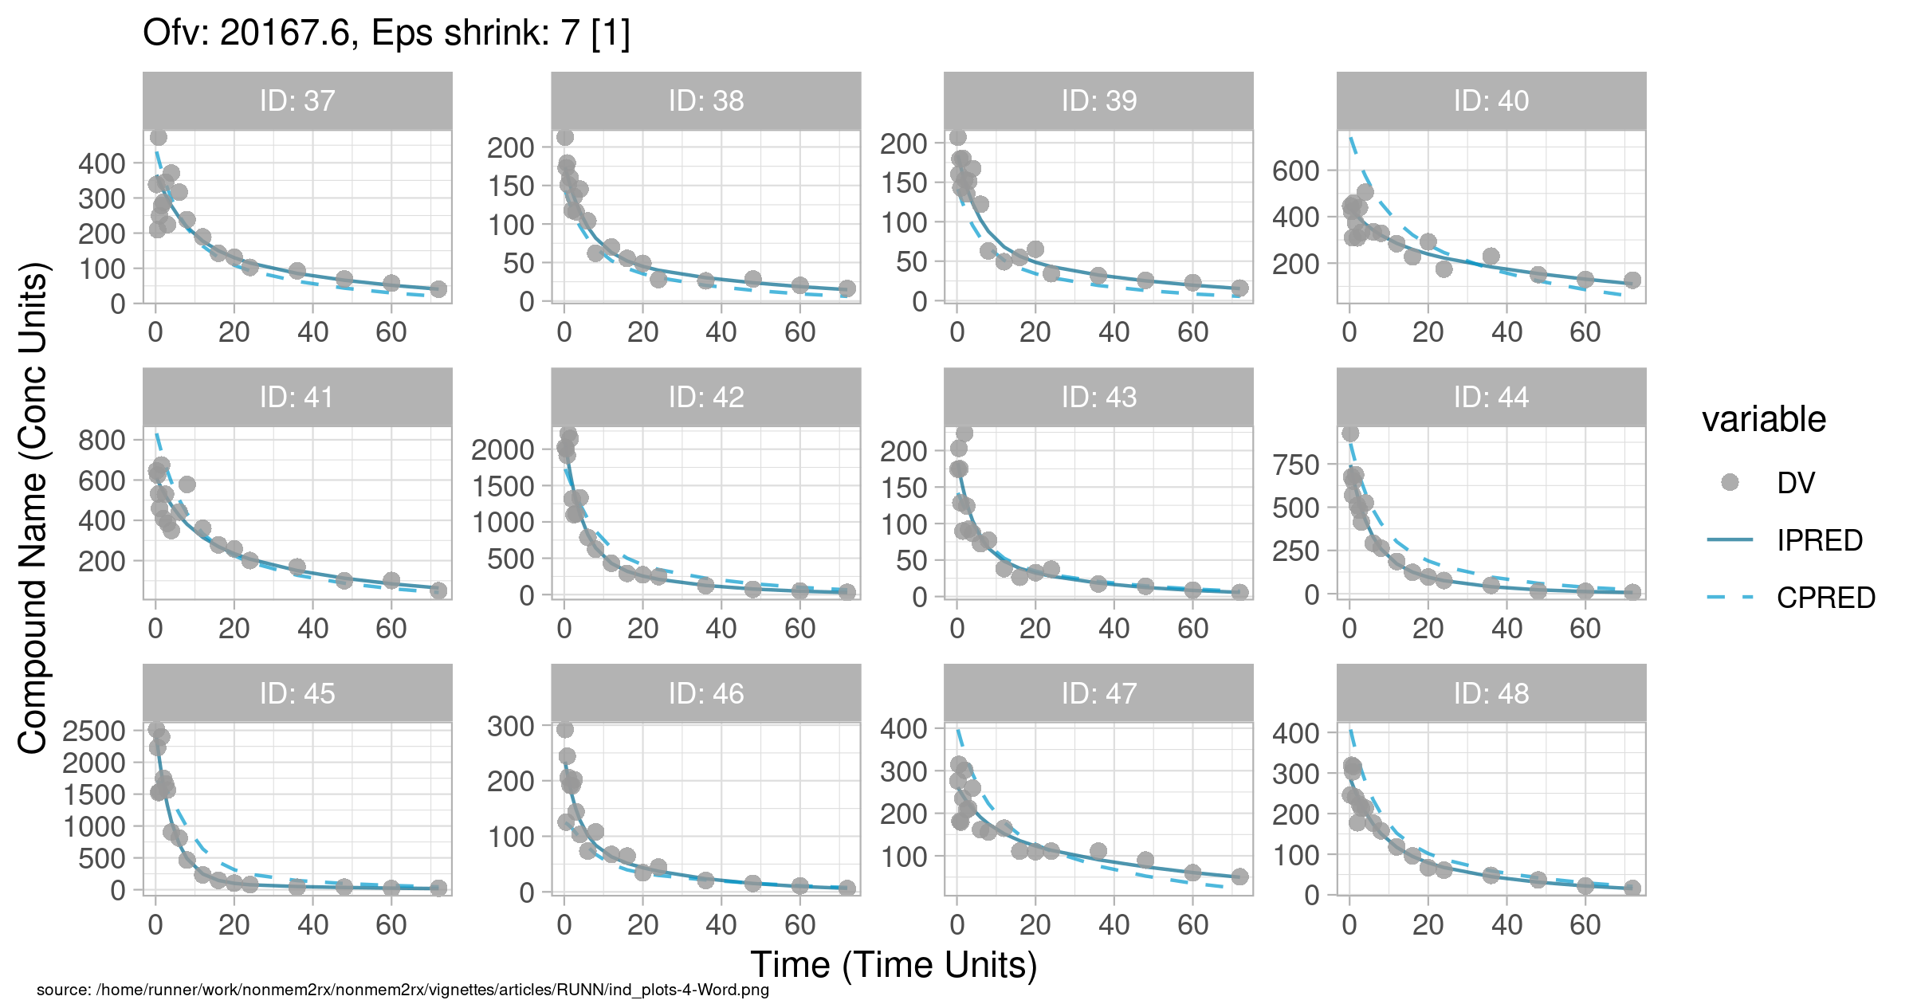
Figure . Individual and population prediction overlay

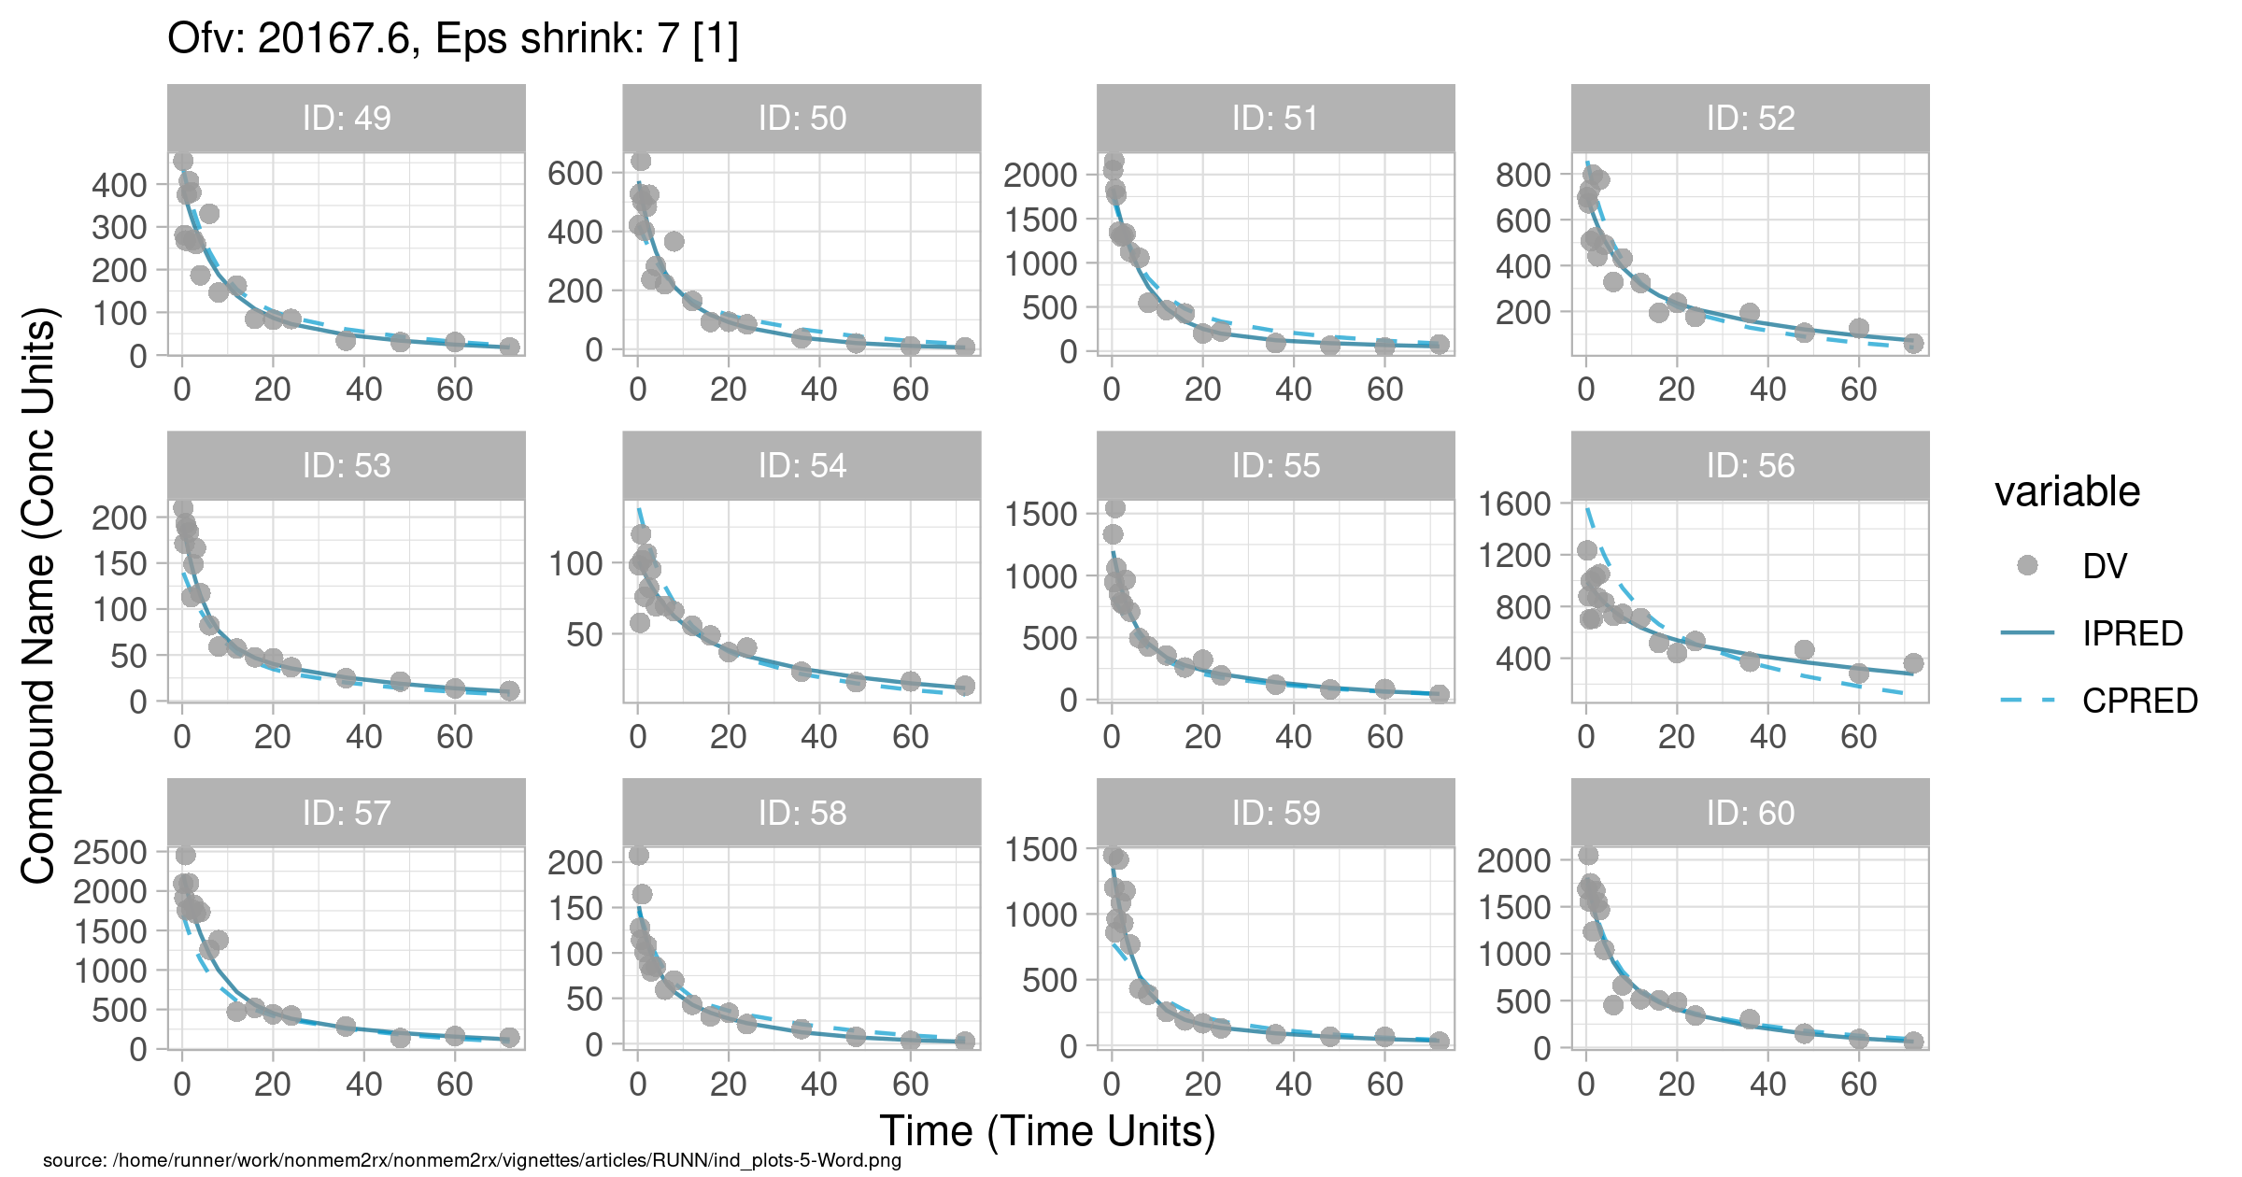
Figure . Individual and population prediction overlay

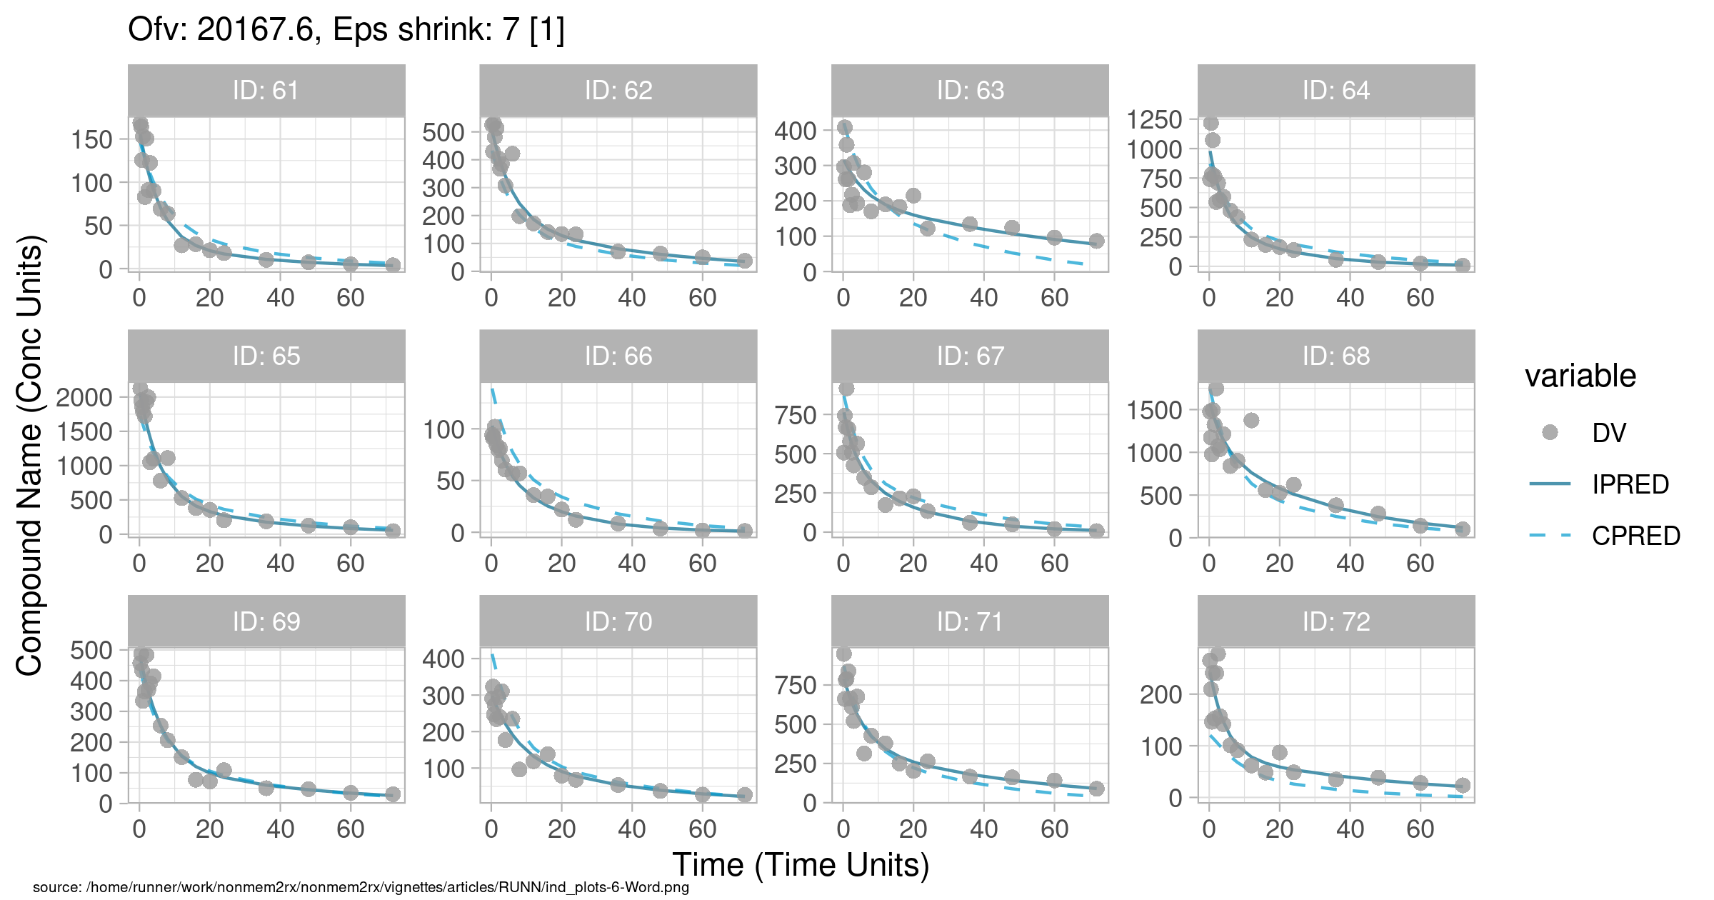
Figure . Individual and population prediction overlay

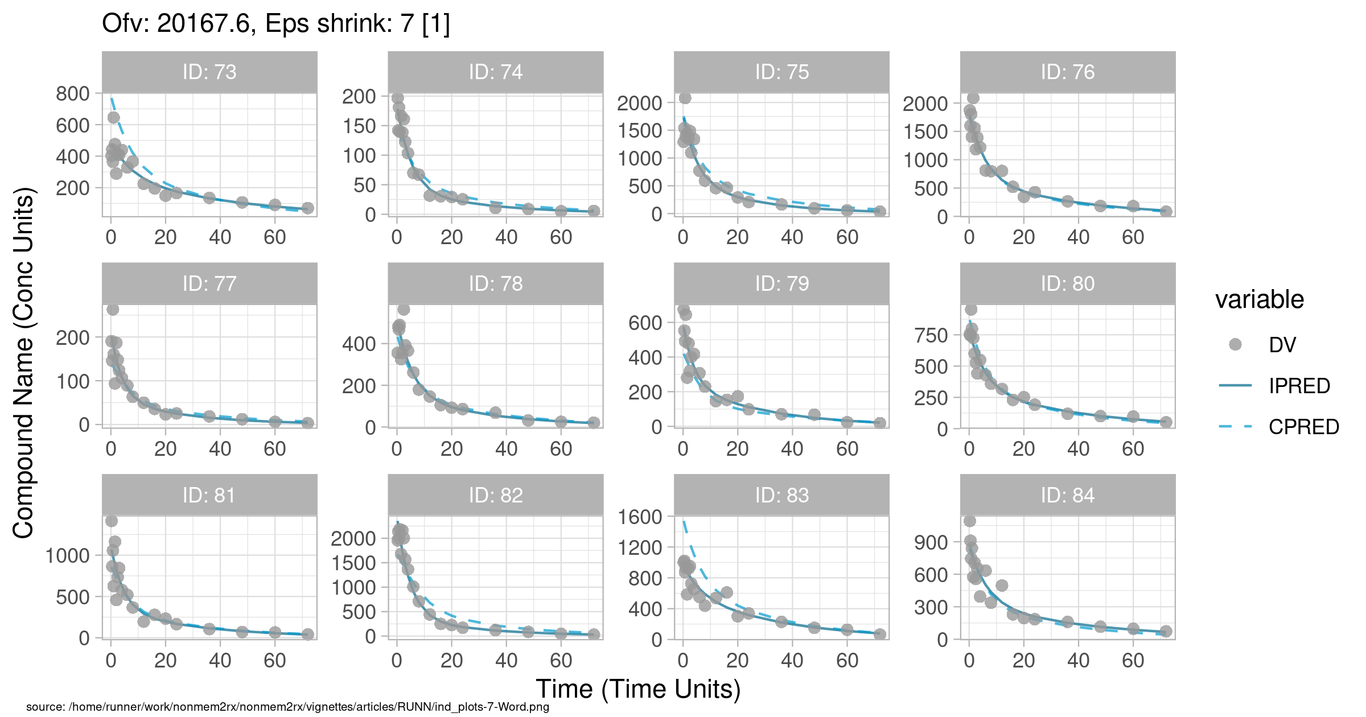
Figure . Individual and population prediction overlay

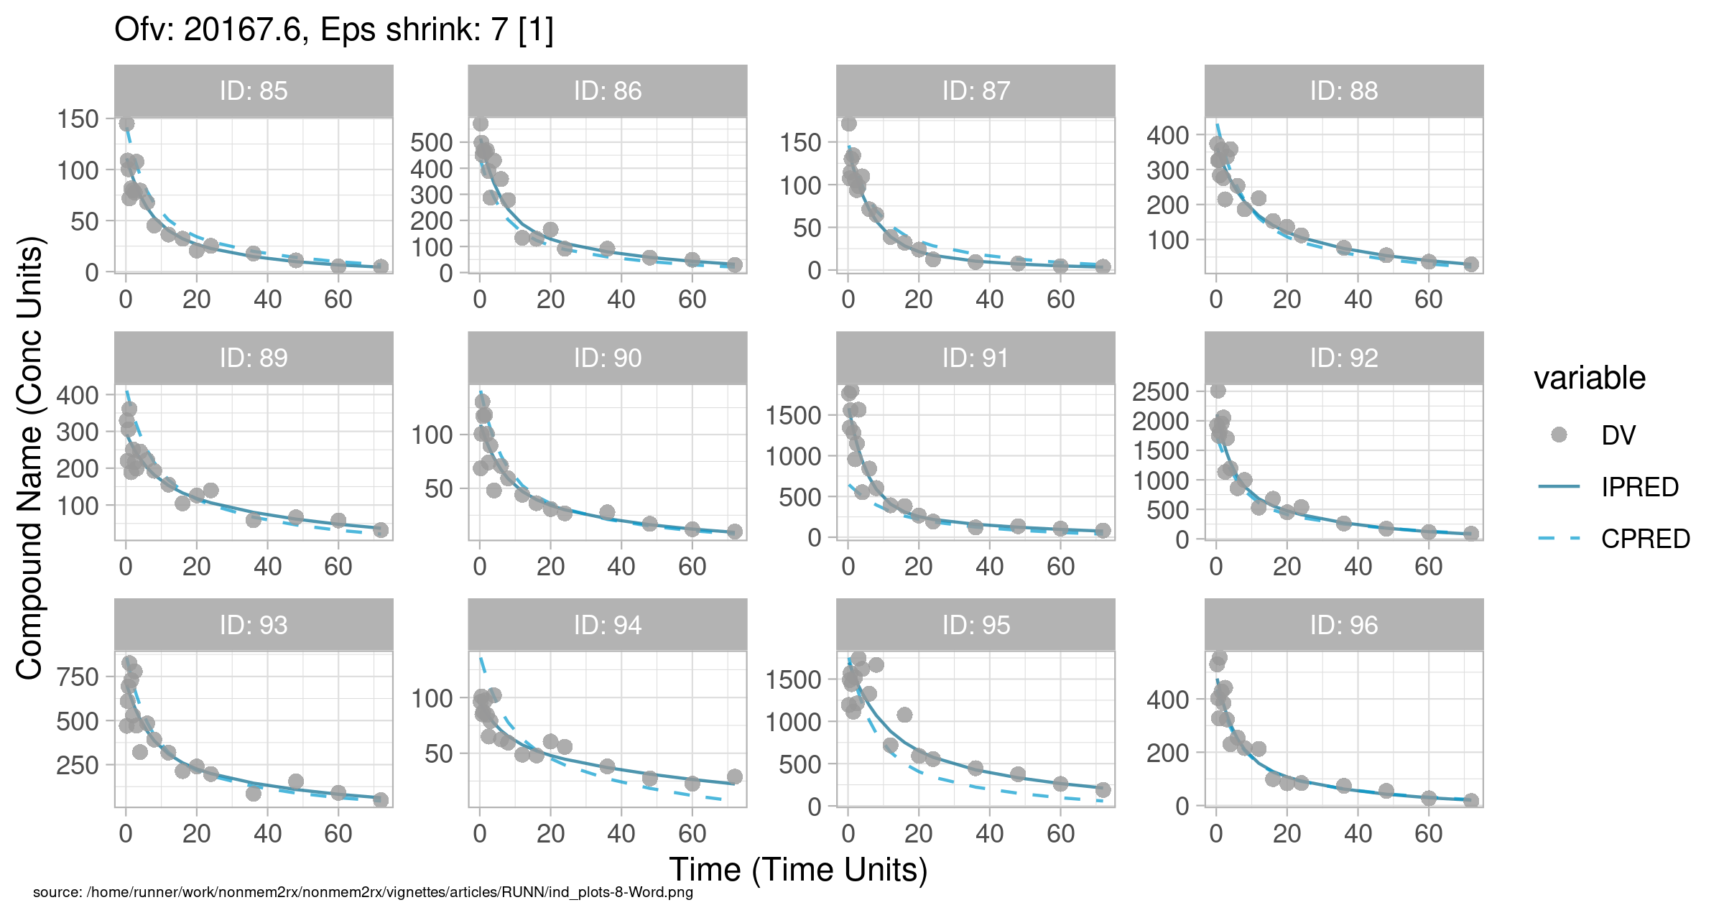
Figure . Individual and population prediction overlay

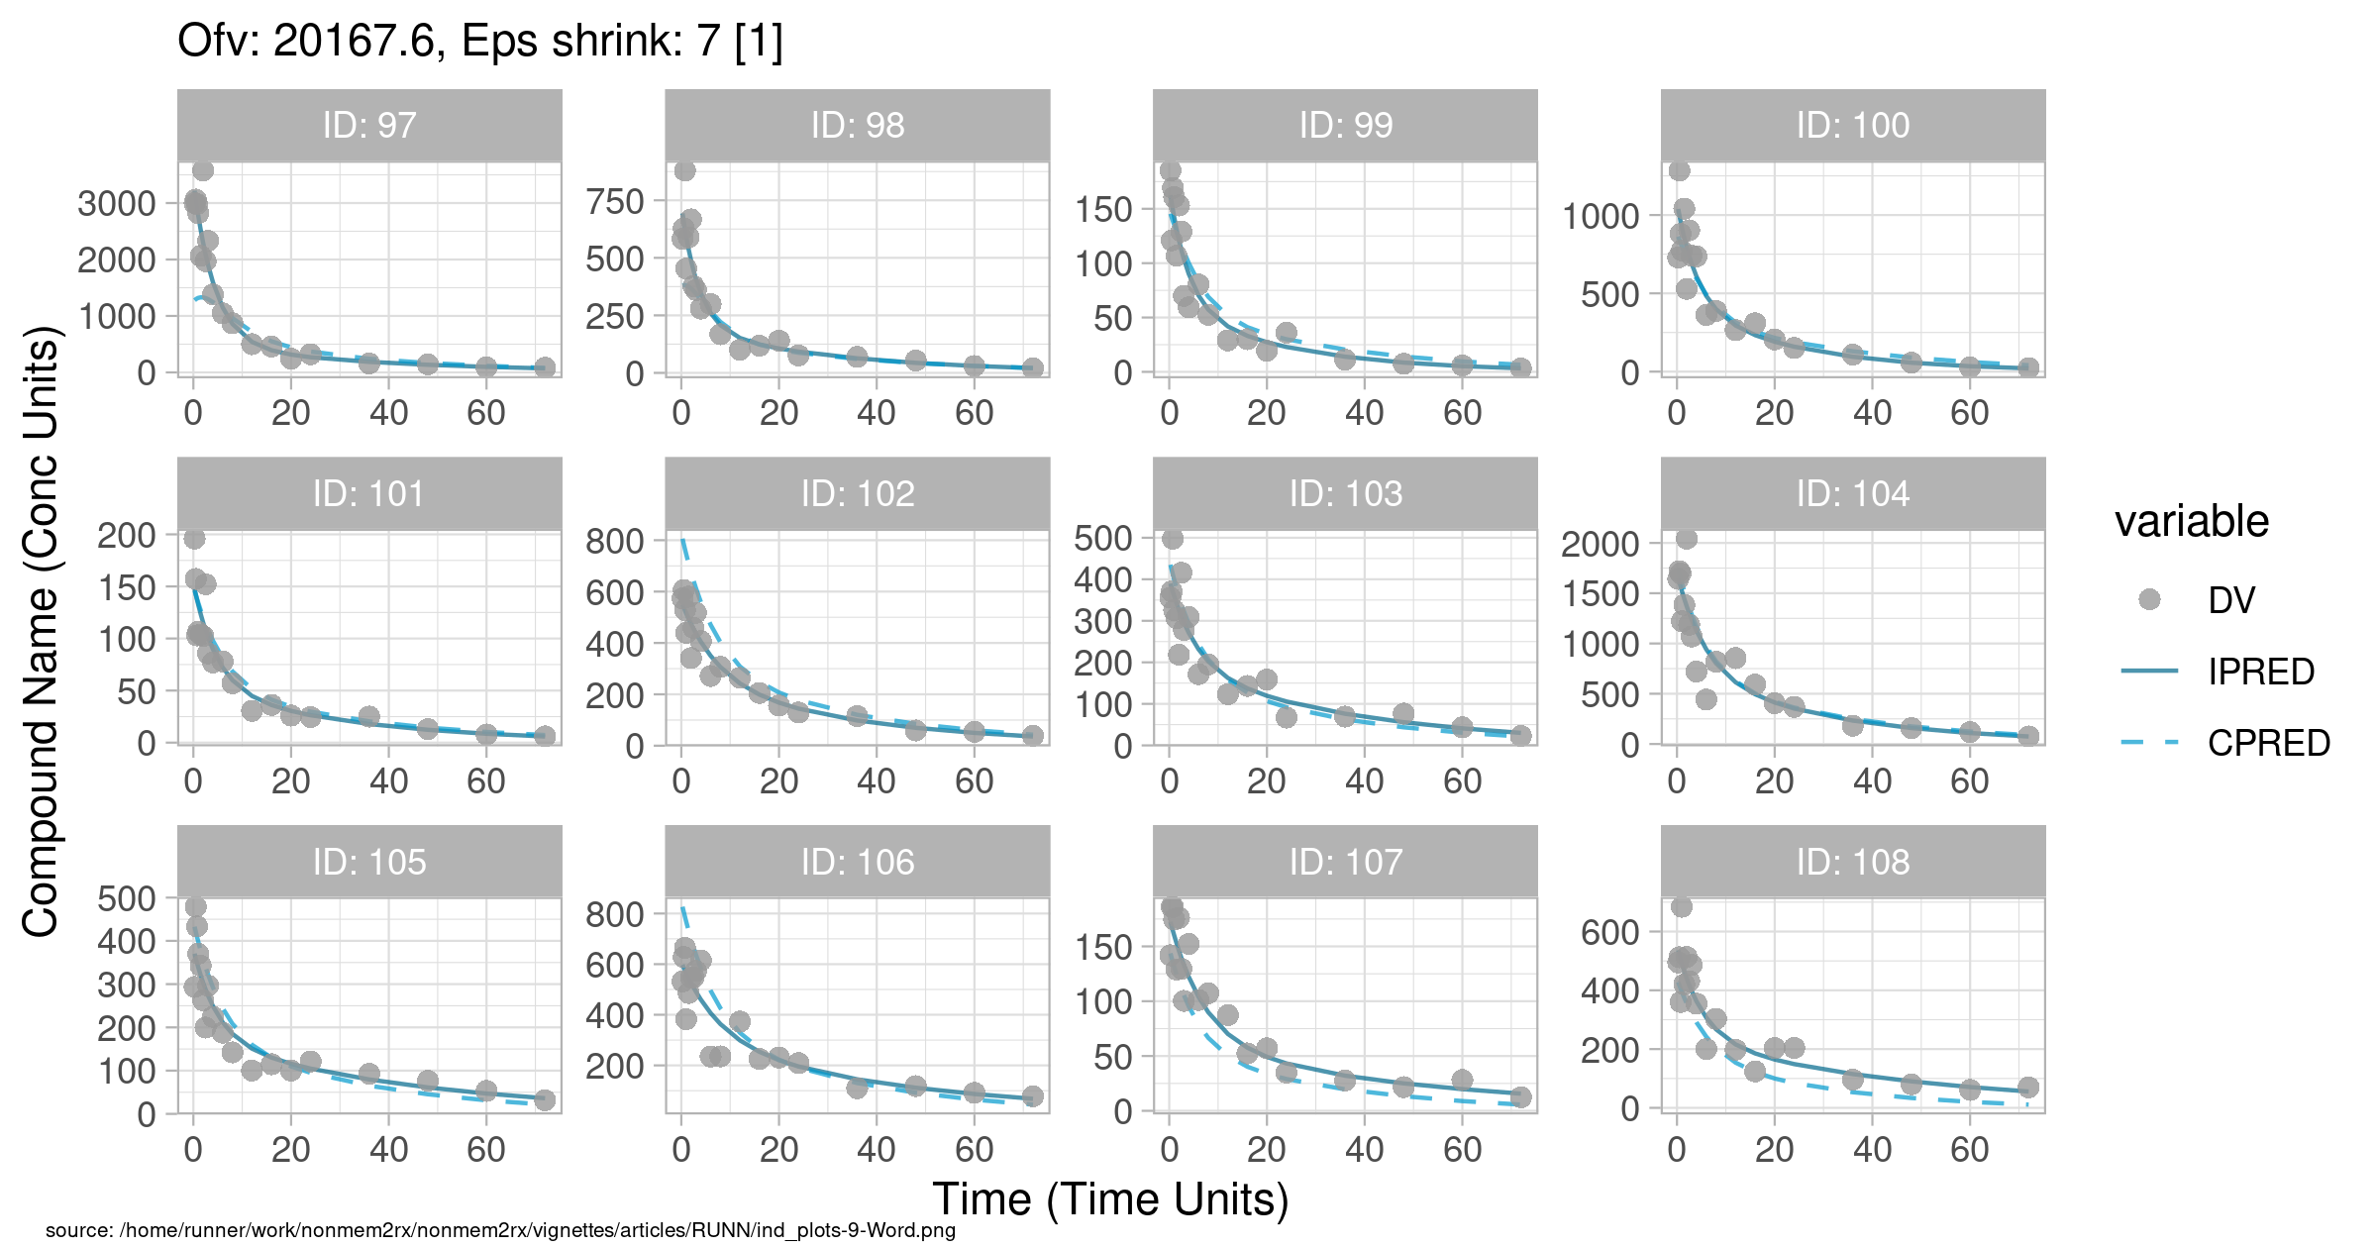
Figure . Individual and population prediction overlay

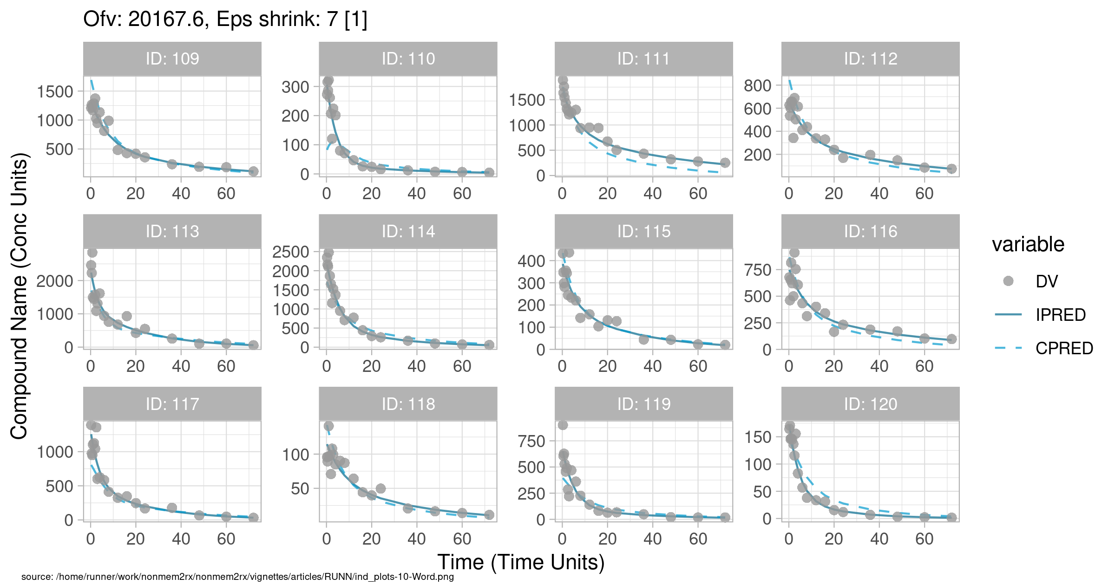
Figure . Individual and population prediction overlay

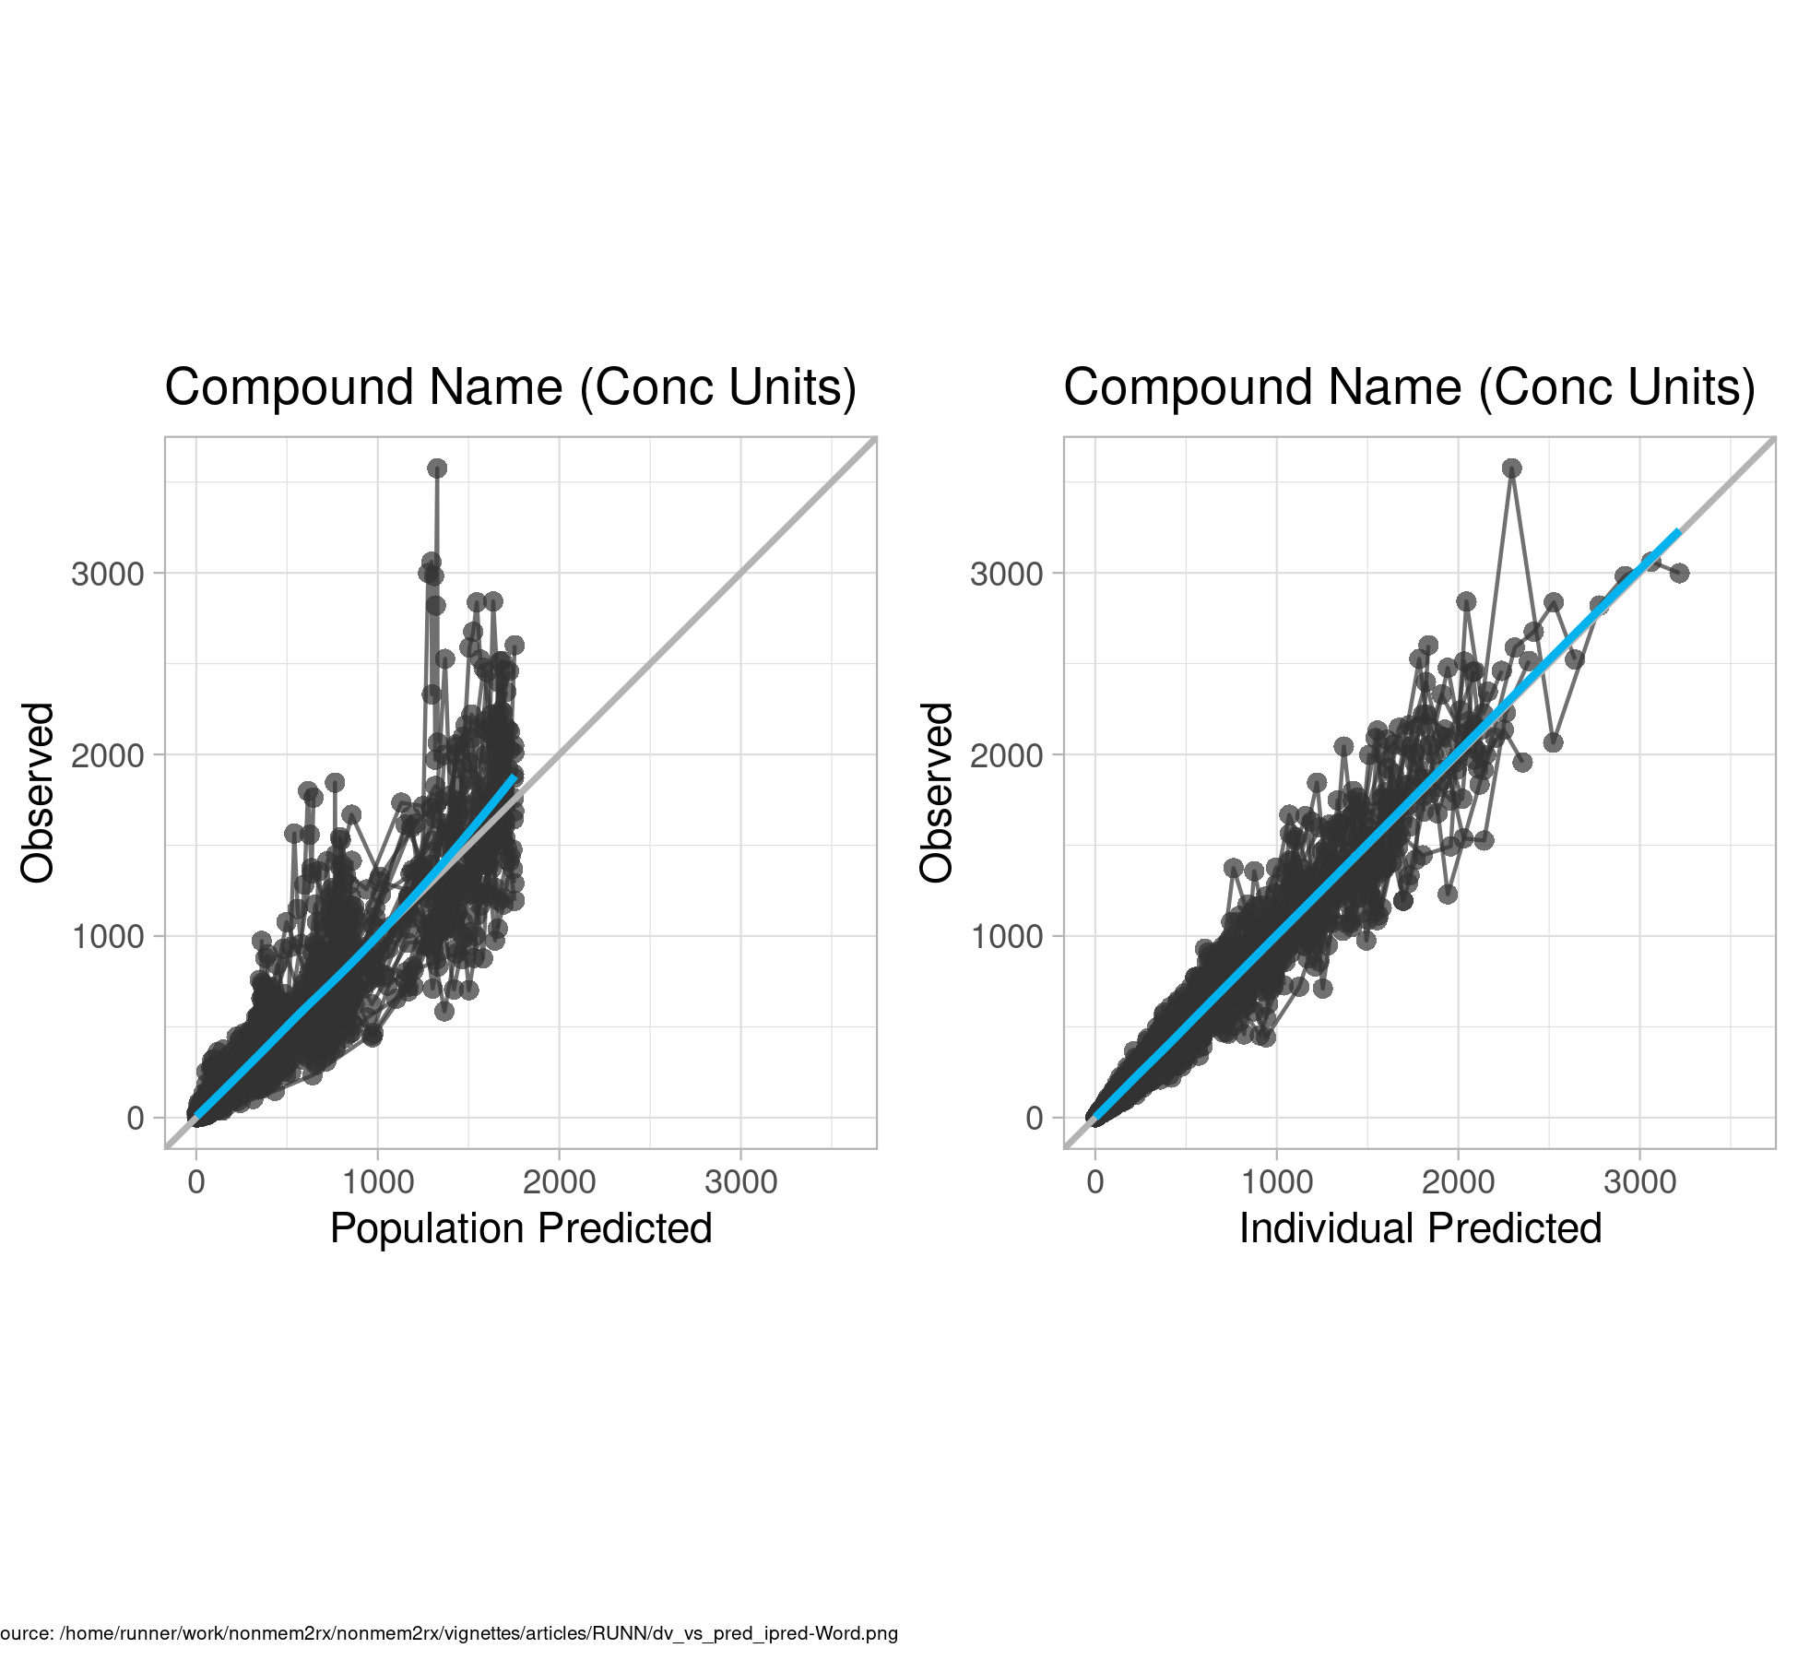
Figure . Observed vs Predicted

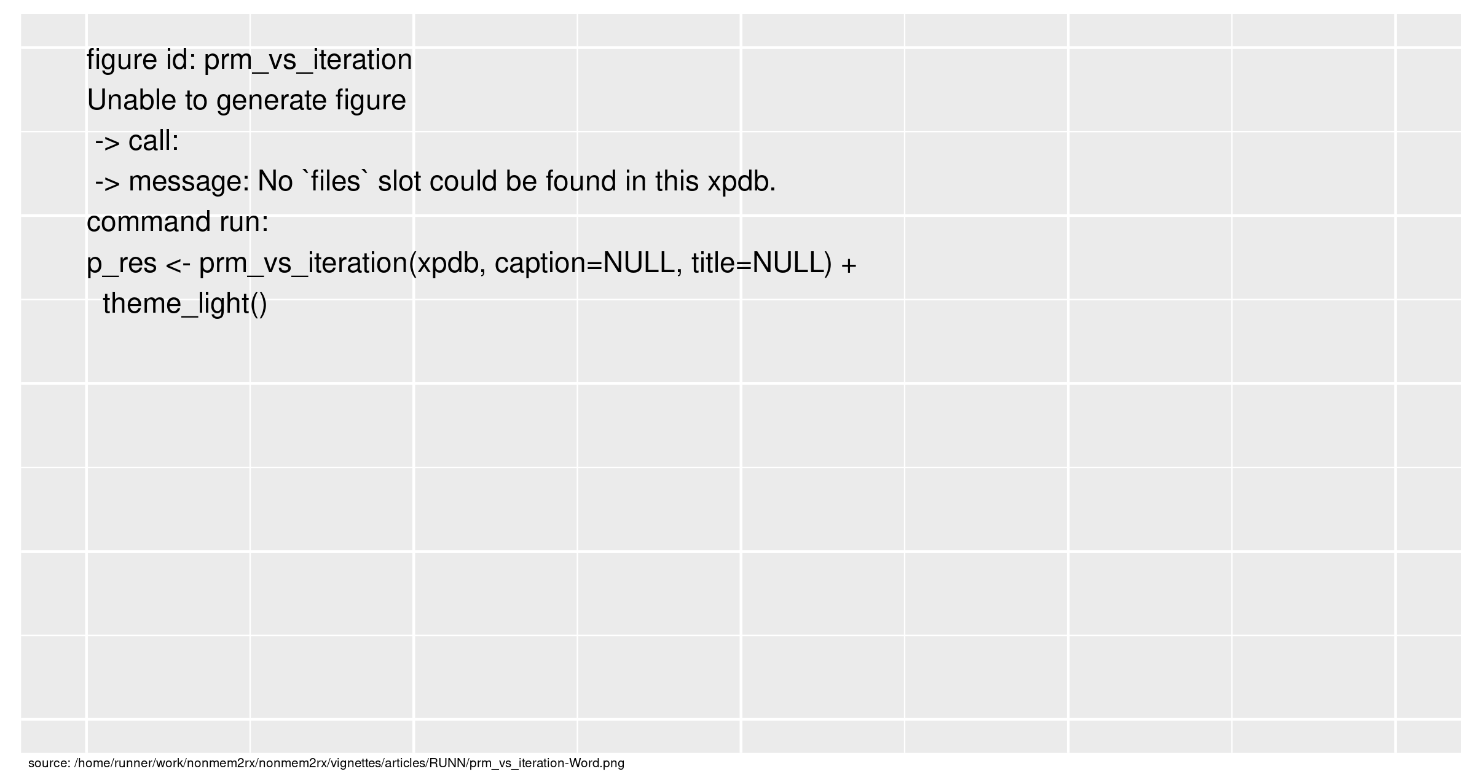
Figure . SAEM Stabilization

